Ivan Pinto
iguedespinto@yahoo.com · 087 7380473 · Portuguese (EU Passport) · linkedin.com/in/ivan-pinto-ireland
Professional Summary
25+ years of experience across consulting, development, architecture, and engineering management, delivering for enterprise clients spanning multiple industries. Experienced in Agile methodologies, leading dispersed teams in client engagements from pre-sales to post-go-live support. Excited to turn ambitious challenges into products and to build and mentor the teams that ship them.
Core Competencies & Skills
Core Technical Architecture · Solution Design · Solution Implementation · Integration · Root Cause Analysis · Problem Solving · Team Leadership · Training · Mentoring · Customer Engagement · Gap Analysis · Trusted Advisor · Customer De-escalation
Salesforce System Architecture · Application Architecture · Integration Architecture · APIs · Data Cloud · Agentforce · Lightning Web Components · Apex
Technologies C# · VB.NET · C · C++ · JavaScript · Python · Node.js · MS SQL Server · MongoDB · Heroku · AWS · Azure
AI and Data Agentic Programming · Claude Code · AI Agents · Genetic Algorithms · Distributed Architectures · Business Intelligence · Data Warehousing
Certifications
Salesforce Certified Application & System Architect — 14 certifications
Agentforce Specialist · Data Cloud Consultant · System Architect · Application Architect · Software Development Lifecycle & Deployment Architect · Identity & Access Management Architect · Integration Architect · Data Architect · Sharing & Visibility Architect · JavaScript Developer I · Platform Developer I · Sales Cloud Consultant · Platform App Builder · Administrator
AZ-900 — Microsoft Azure Fundamentals
thePowerMBA — the digital MBA program
Career History
EY — Dublin, Ireland 2026
Salesforce Technical Architect · Director
- Created the Salesforce Assessor, an internal tool to automate Salesforce platform assessments — estimated to cut data extraction and initial processing effort by 80%, enabling a free-tier, pre-packaged assessment service.
- Led the Salesforce workstream of an internal initiative to create an Agentic Enterprise sales demo, redesigning the Lead-to-Cash process with an agentic approach spanning Salesforce and SAP.
- Supported tenders and commercial proposals.
Salesforce — Dublin, Ireland 2025 – 2026
Principal Technical Architect
- Driving technical strategy in pre-sales engagements for the SMB segment across EMEA, spanning the full spectrum of Salesforce Cloud products and platform services.
- Specialised in enterprise integration patterns, security and compliance architecture, and multi-cloud implementations, including industry solutions such as Financial Services Cloud.
- Delivered internal enablement sessions for internal teams and the graduate program.
Asset Class — Startup Salesforce ISV · Dublin, Ireland 2022 – 2025
Tech Lead
- Designed and implemented complex product modules in Salesforce — rules-based waterfall distribution, dynamic DocuSign generator, and configurable questionnaires; Instrumental to gain new business.
- Translated business requirements into detailed work items, serving as the bridge between the developer team and project management.
- Technical lead for sales-team prospect calls, presenting new features and fielding technical questions.
- Reworked customer onboarding processes and tools, halving new-customer onboarding time.
- Developed an AI proof of concept using Salesforce Agentforce and Palantir.
ClaimVantage / Majesco — Startup Salesforce ISV · Dublin, Ireland 2019 – 2022
Engineering Director 2022
- Prepared budgets for differing product-development and support strategies.
- Led a world-class engineering team of 15 direct reports across the US, Australia, Ireland and India; recruited, interviewed and established an offshore development team in India.
- De-escalated at-risk accounts with strategic product roadmaps aligned to Customer Success objectives, driving a 20% decrease in churn risk.
- Spearheaded scalability initiatives for customers with massive data volumes (e.g. Amazon), introducing QA stress tests and performance benchmarks to keep new releases performant.
Engineering Manager 2021 – 2022
- Led the Dublin Development and QA teams (7 direct reports) plus outsourced augmented teams in India.
- Built an onboarding framework that cut ramp-up of entry-level members by 50%, training developers with no prior Salesforce experience.
- Introduced a technical-exercise-based hiring process, cutting hiring time 3× and producing developers with Salesforce exposure before joining.
- Technical point of contact with the Salesforce Technical Account Manager.
Technical Team Lead 2020 – 2021
- Led the Lightning Project, migrating from Salesforce Classic to Lightning Experience.
- Led the design of the microservices architecture to leverage existing functionality from other Majesco solutions.
- Achieved Salesforce Security Review and Veracode certification through structured code review; trained and mentored new developers.
Principal Engineer 2019 – 2020
- Delivered the proof of concept for the new user experience, migrating from Visualforce to Lightning Components.
- Customer presentations, demos and QA sessions with key customers on the new Lightning UX.
- Implemented strategy for common data-model and cross-package communication.
Property Button — Startup · Bray, Ireland 2017 – 2019
Senior Salesforce Developer
- Built Lightning Aura Components for the Customer Portal.
- Introduced a configurable form framework enabling hotfixes released independently of the bi-weekly deployment cycle, reducing resolution time by up to 75%.
Clout Partners — Salesforce Consultancy · Dublin, Ireland 2016 – 2017
Solutions Architect
- Tech Team Lead, consistently exceeding utilisation across Salesforce, Marketo and Pardot engagements.
- Close collaboration with the sales team — estimating effort for SOWs, building and presenting proof-of-concept demos.
Earlier Experience
Marketo EMEA — Dublin, Ireland 2014 – 2016
Technical Team Lead (2015–2016) · Senior Technical Consultant (2014–2015)
- Lead technical consultant on Marketo EMEA's largest projects (Deloitte UK, Schneider Electric, Bank of New Zealand), from SOW through full delivery and acceptance. Built the reusable Marketo Data Loader and negotiated 6 new API endpoints that reshaped enterprise integrations; pristine utilization record, recurrently re-requested by clients.
Smartbox — Dublin, Ireland 2012 – 2014
Senior Application & Integration Engineer
- Owned all CRM systems across the European group, including budget and vendor management. Re-engineered data flows between CRM and ERP — cutting monthly data-correction requests by 90% — and led an on-premise CRM datacentre migration, championing consolidation onto Salesforce.com.
Additional Logistics — Lisbon, Portugal 2008 – 2012
Development Team Lead
- Led development teams across Portugal and Spain plus external contractors. Drove ERP consolidation across the group, delivered a Microsoft BI solution spanning customer service, distribution, warehouse and sales, and built the Nespresso pick-to-light warehouse fulfilment software. Delivered further system integrations, web applications and BI for clients including Unilever, Pepsico and Matutano.
Inovodecor — Lisbon, Portugal 2003 – 2009
IT Manager · Senior IT Engineer
- Revamped IT infrastructure and re-engineered internal processes — over six years revenue tripled with half the original workforce. Led the migration to Microsoft Navision and built a Business Intelligence solution on the Microsoft BI stack.
Deloitte Consulting — Lisbon, Portugal 1999 – 2003
Consultant (2000–2003) · Business Analyst (1999–2000)
- Certified Siebel CRM consultant at full utilization. Delivered design, data migration and integrations for major enterprise clients including Philip Morris across multiple countries — integrations that supported Philip Morris France flawlessly for 8 years.
Education
MSc, Computer Science — Specialization in Industrial Automation
5-year engineering degree (pre-Bologna, Master's equivalent)
Instituto Superior Técnico — Technical University of Lisbon, Portugal
Languages
English & Portuguese — Bilingual fluency
French & Spanish — Intermediate · fluent reading and comprehension; conversational speaking
Role mix per job
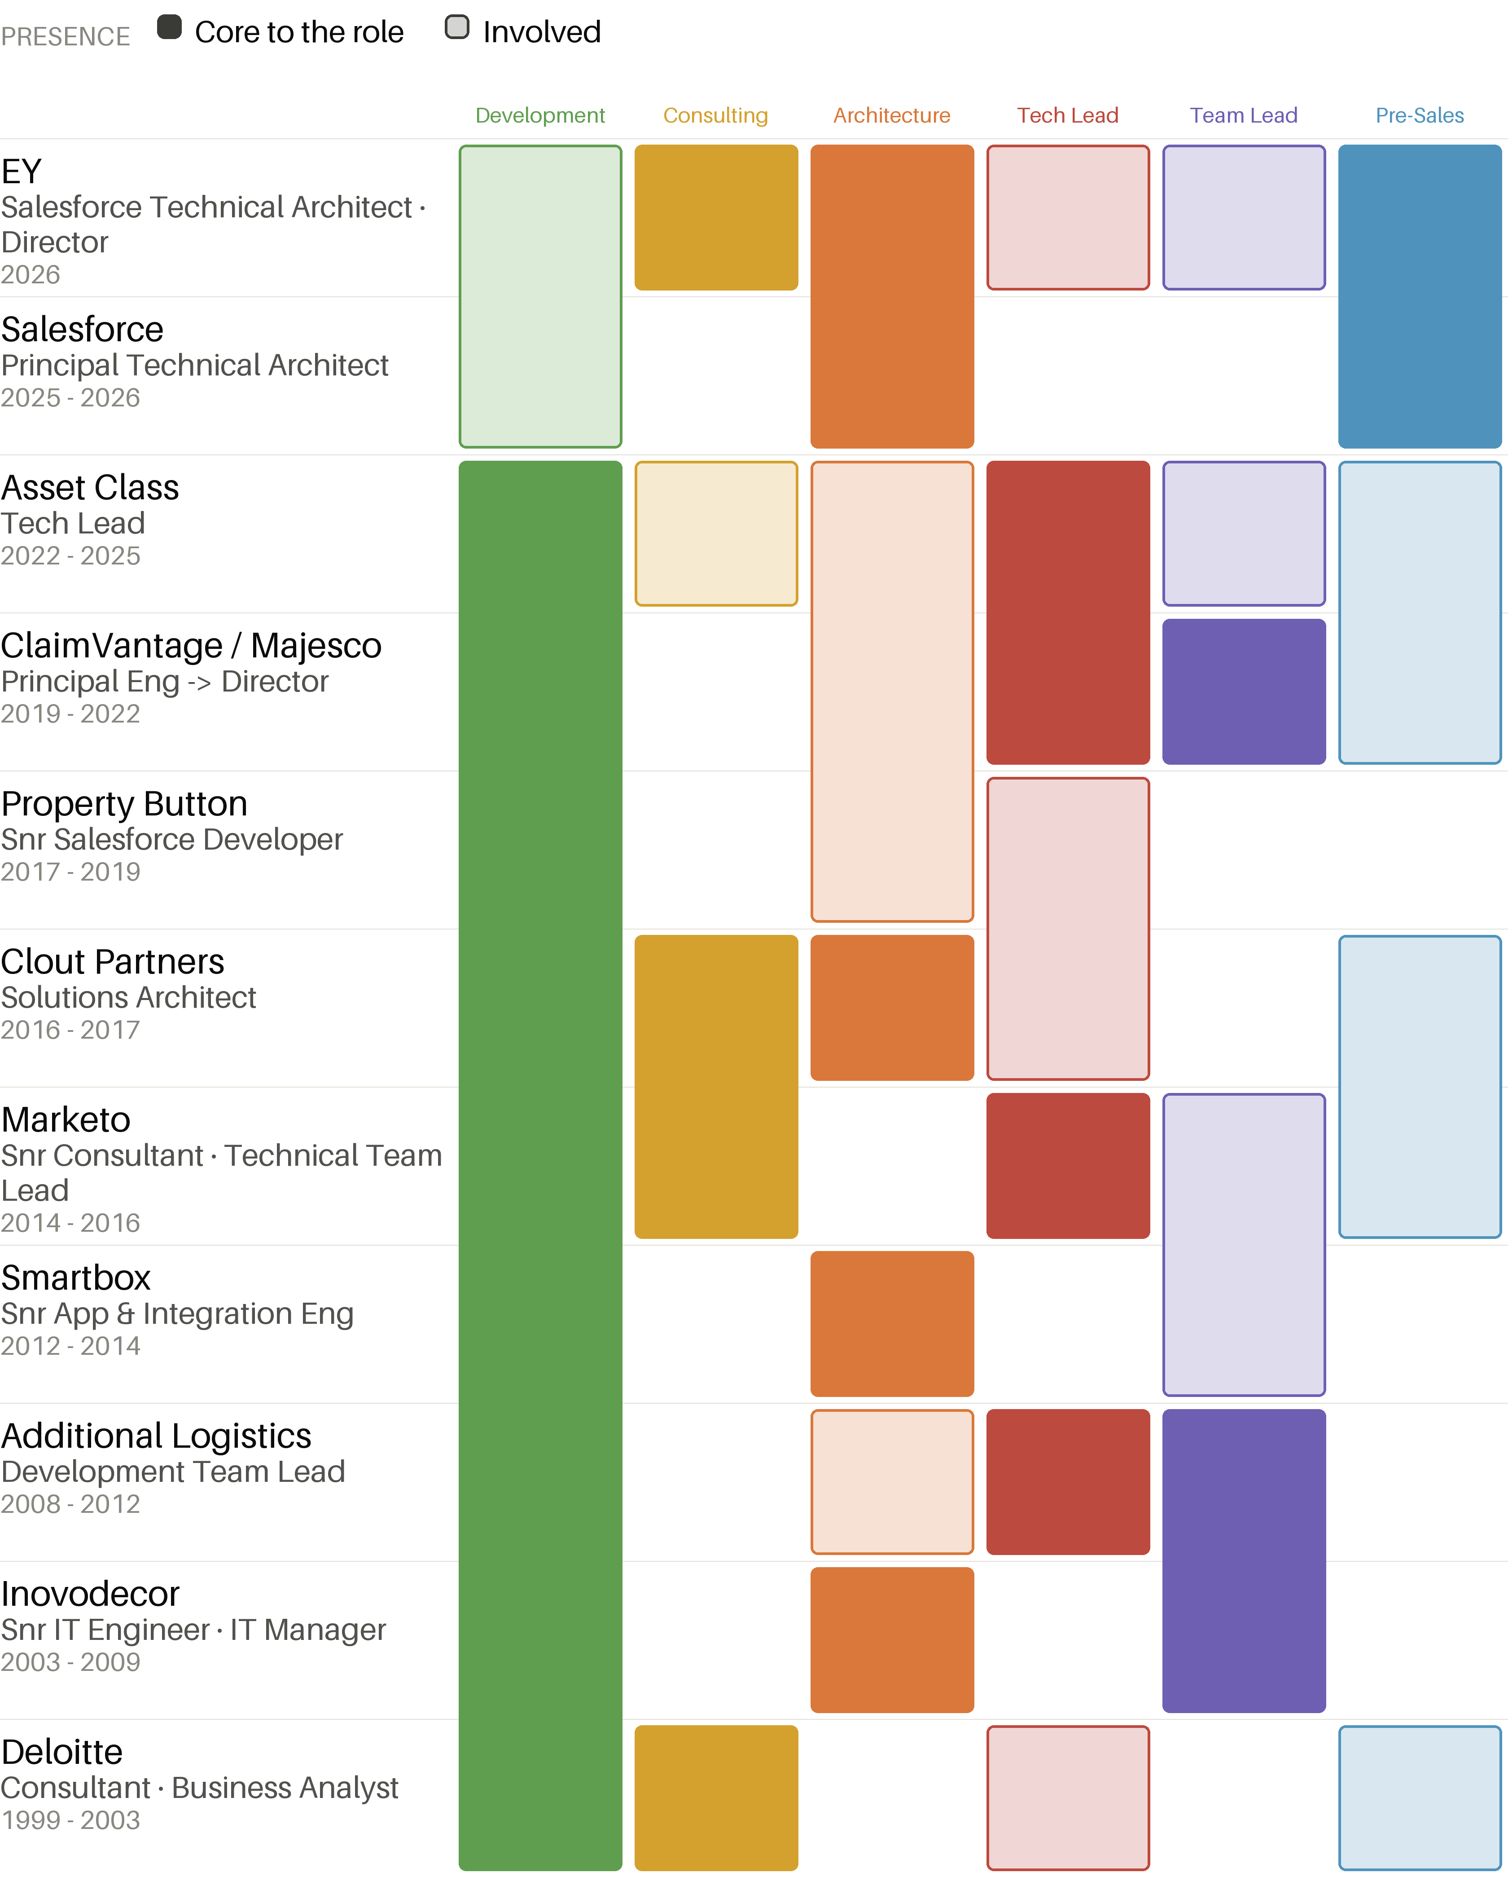
Technology per job
